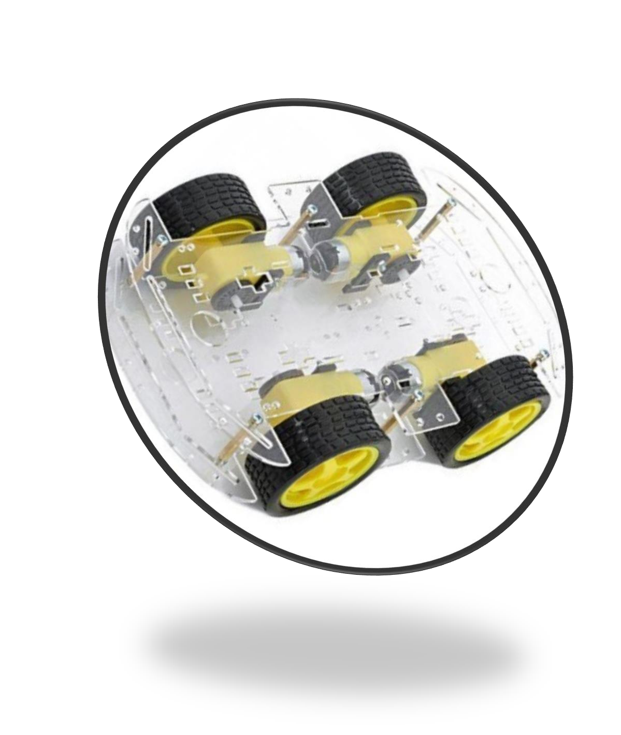

- Project introduction: 2
- High Level Design 2
  - Layered Architectures: 2
  - Modules description: 3
    - MCAL 3
    - HAL: 3
    - Application: 3
  - Drivers’ documentation:- 4
    - DIO Driver 4
Description: 4
Functions 4
    - Timer Driver: 4
Description 4
Functions 4
    - Interrupt Driver: 5
Description 5
Functions 5
    - Button Driver 5
Description 5
Functions 5
Driver: LCD v.
Description: 5
Functions 5
vi. Motor Driver 6
Description 6
Functions 6
vii. ICU Driver 6
Description 6
Functions 6
vii. US Driver 6
Description 6
Functions 6
- Low Level Design 6
  - Flow Charts : 6
- MCAL Layer 6
  - DIO Functions 6
  - External Interrupt Functions 7
  - Timers Function 9
  - ICU Function 9
- HAL Layer 12
  - LCD Functions 12
  - Button Functions: 16
  - Motor Functions 17
  - Key Pad Functions 19
  - Ultra Sonic Functions 19
  - Configurations: 20
    - Dio 20
    - EX_Interrupt 22
    - Timers: 23
    - LCD 24

Project introduction:

The aim of this project is to design a four wheels driving car that has the ability to avoid any type of obstacle with a self-enhancing mechanism that changes speed and direction according to the circumstances

High Level Design:

Layered Architectures:

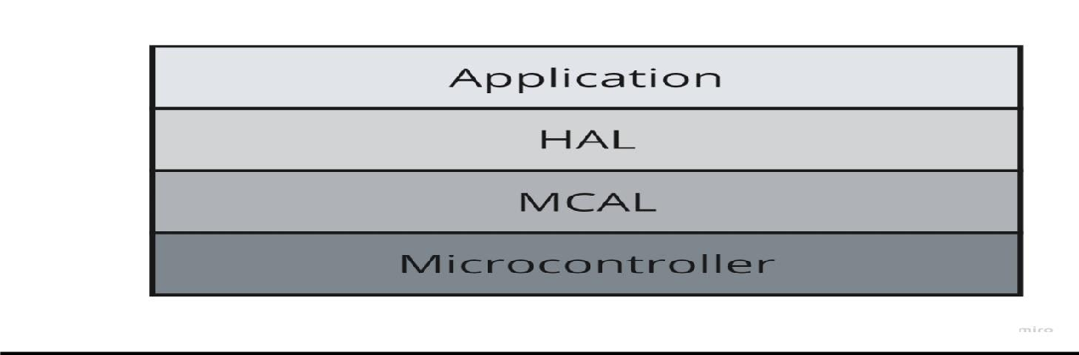
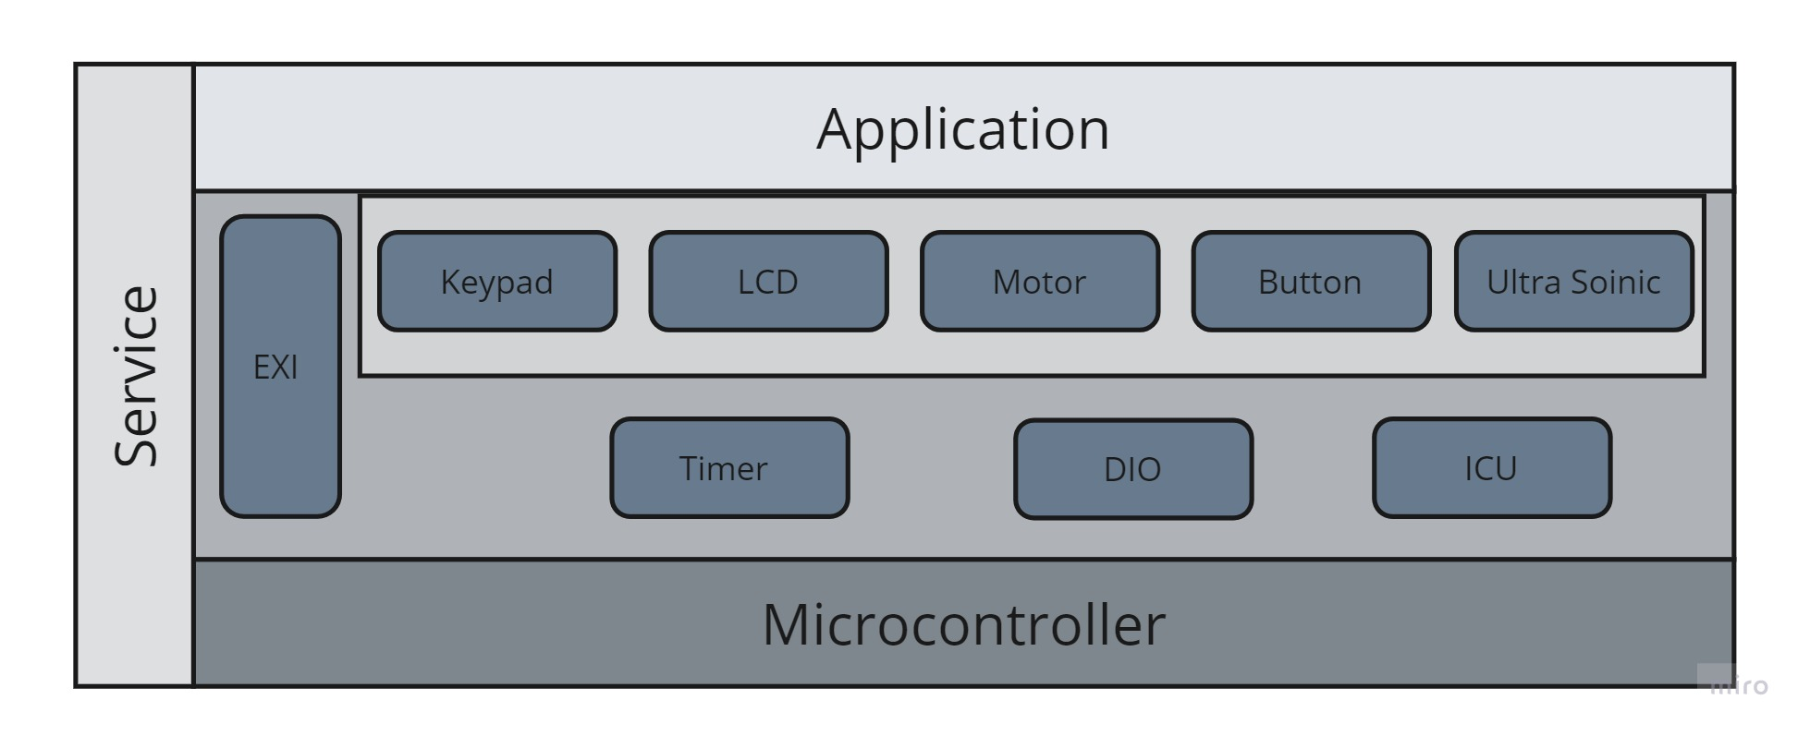

Modules description:

    - MCAL: It is a software module that directly accesses on-chip MCU peripheral modules and external devices that are mapped to memory, and makes the upper software layer independent of the MCU.

    - HAL: It is a layer of programming that allows The Application Layer to interact with a hardware device at a general or
abstract level rather than at a detailed hardware level.

    - Application: Application Layer: This is the topmost layer of the software stack, which contains the actual application logic. It
interacts with the lower layers to perform its tasks. It is responsible for implementing the desired functionality of the system.

Drivers’ documentation:-

DIO Driver:
Description: The DIO (Digital Input Output) driver is responsible for setting up the digital pins of the microcontroller to either input or output mode. This driver will be used to control the buttons and LEDs.

Functions:

DIO_ERROR_TYPE DIO_INITPIN(DIO_PIN_TYPE PIN,DIO_PINSTATUS_TYPE STATUS); DIO_ERROR_TYPE DIO_WRITEPIN(DIO_PIN_TYPE PIN,DIO_VOLTAGE_TYPE VOLTAGE); DIO_ERROR_TYPE DIO_READPIN(DIO_PIN_TYPE PIN,DIO_VOLTAGE_TYPE* VOLT);
void DIO_TogglePin(DIO_PIN_TYPE pin);

Timer Driver:
Description: The Timer driver is responsible for setting up and controlling the timers of the microcontroller. This driver will be used to create the timing delays required in the project.

Functions:

//timer 0 prototypes

Timer_ErrorStatus TIMER_0_init(Timer_Mode mode); Timer_ErrorStatus TIMER_0_start(Timer_Prescaler prescaler); void TIMER_0_stop(void);
Timer_ErrorStatus TIMER_0_setIntialValue(uint8_t value); Timer_ErrorStatus TIMER_0_OvfNum(double overflow);
void TIMER_0_DELAY_MS(double _delay);

//timer 2 prototypes

Timer_ErrorStatus TIMER_2_init(Timer_Mode mode); Timer_ErrorStatus TIMER_2_start(Timer_Prescaler prescaler); void TIMER_2_stop(void);
Timer_ErrorStatus TIMER_2_setIntialValue(uint8_t value); Timer_ErrorStatus TIMER_2_OvfNum(double overflow);
void TIMER_2_DELAY_MS(double _delay); void TIMER_2_INT();

//PWM Function prototype

void TIMER_0_pwm(float intial);

Interrupt Driver:
Description: The Interrupt driver is responsible for setting up and controlling the interrupts of the microcontroller. This driver will be used to detect button presses.

Functions:

EN_int error_t EXI_Enable (EN_int_t Interrupt); EN_int error_t EXI_Disable (EN_int_t Interrupt);
EN_int error_t EXI_Trigger(EN_int_t Interrupt,EN_trig trigger); void EXI_SetCallBack(EN_int_t Interrupt,void(*ptrf)(void));

Button Driver:
Description: The Button driver is responsible for setting up and controlling the buttons of the microcontroller. This driver will be used to detect button presses.

Functions:

BUTTON_ERROR_TYPE Button_INIT(DIO_PIN_TYPE PIN);
BUTTON_ERROR_TYPE Button_read(DIO_PIN_TYPE PIN,DIO_VOLTAGE_TYPE*VOLT);

LCD Driver:
Description: This driver controls the LCD display and provides an interface between the microcontroller and the LCD hardware, allowing the microcontroller to display the temperature readings and messages to the user..

Functions:

void LCD_WRITE_COMMAND(uint8_t a_COMMAND); void LCD_WRITE_DATA(uint8_t a_DATA);
void LCD_INIT(void);
void LCD_Write_String(uint8_t*a_String); void LCD_Write_Number(uint32_t a_number); void LCD_Clear(void);
void LCD_GoTo(uint8_t a_line,uint8_t a_cell); void LCD_Write_Charecter(uint8_t a_char);

Motor Driver:
Description: The Motor driver is responsible for setting up and controlling the motors of the car. This driver will be used to control the speed and direction of the motors.

Functions:

void Motors_init(void); void Motors_Start(void); void Motors_Rotating(void); void Motors_Stop(void);

VII. ICU Driver:
Description: the ICU module is used to capture a timer value from one of two selectable time bases on the occurrence of an event on an input pin.

Functions:

void ICU_init(void);

VIII. Ultra Sonic Driver:
Description: An ultrasonic sensor is an electronic device that measures the distance of a target object by emitting ultrasonic sound waves, and converts the reflected sound into an electrical signal
Function:

void US_init(void);
void US_GetDistance(void);

Low Level Design:

Flow Charts :

MCAL Layer:

DIO Functions:

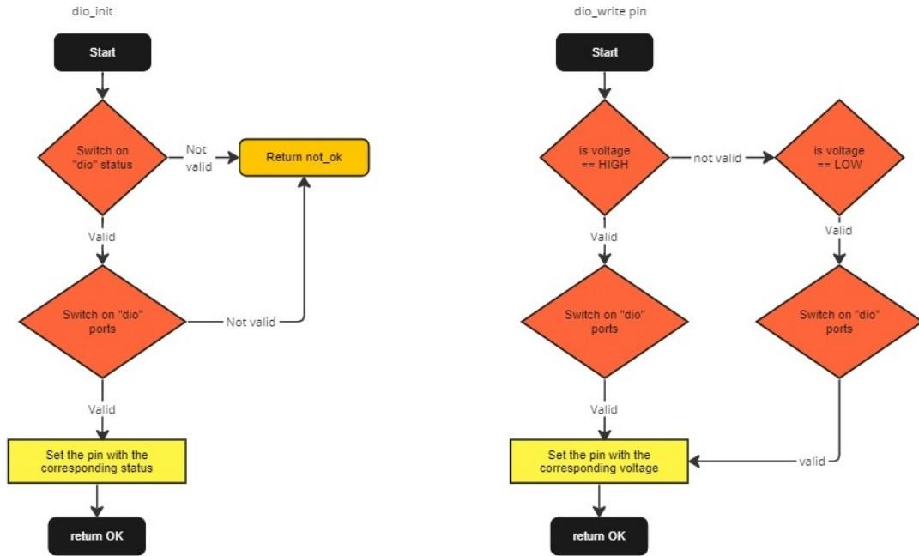

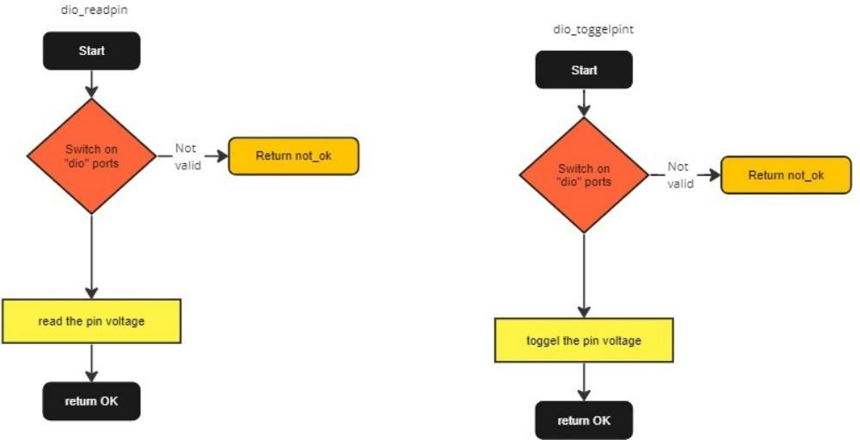

External Interrupt Functions

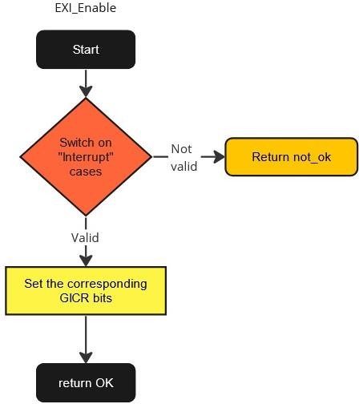
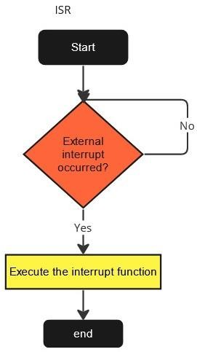

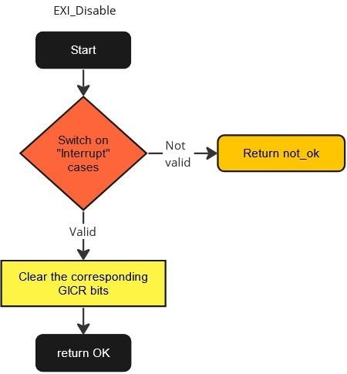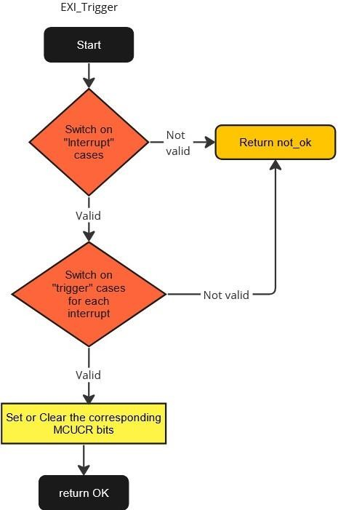

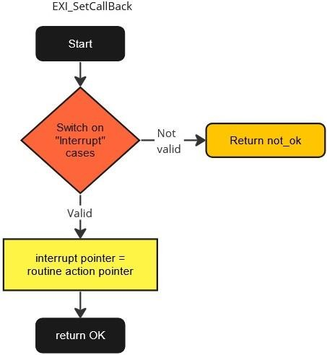

Timers Function
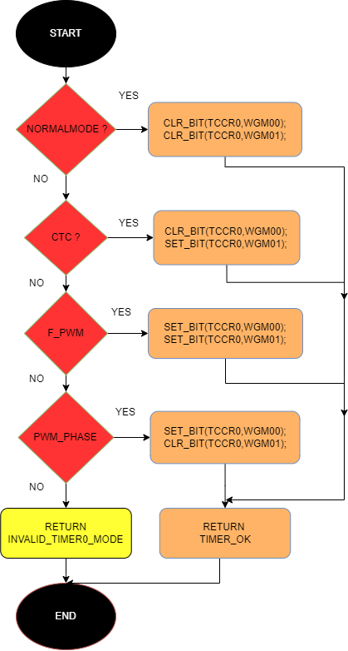
Timer_0_Init

Timer_0_OVFNum
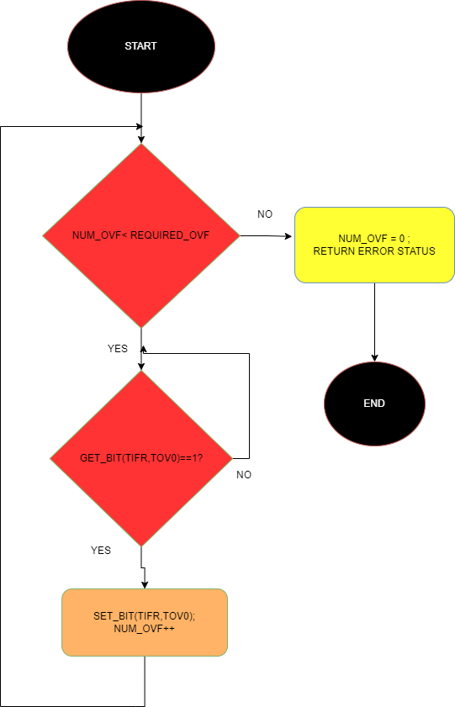

Timer_0_PWM

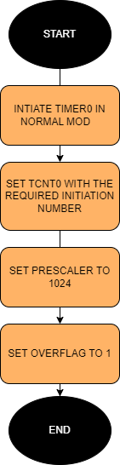

Timer_0_Start
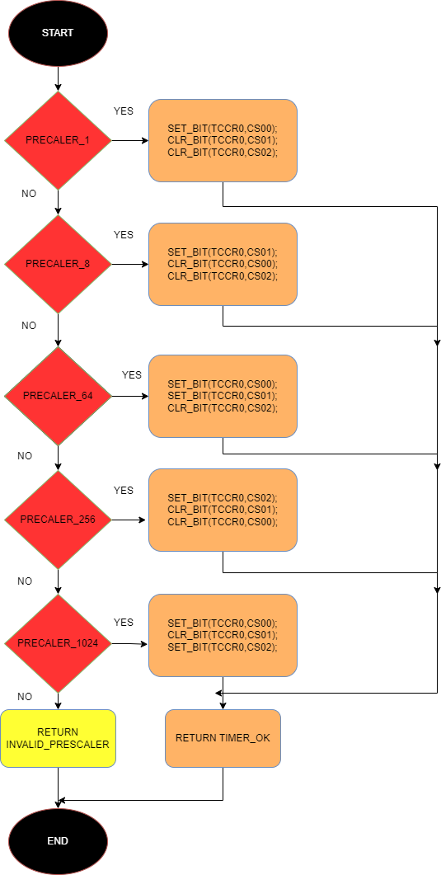

- ICU Function:
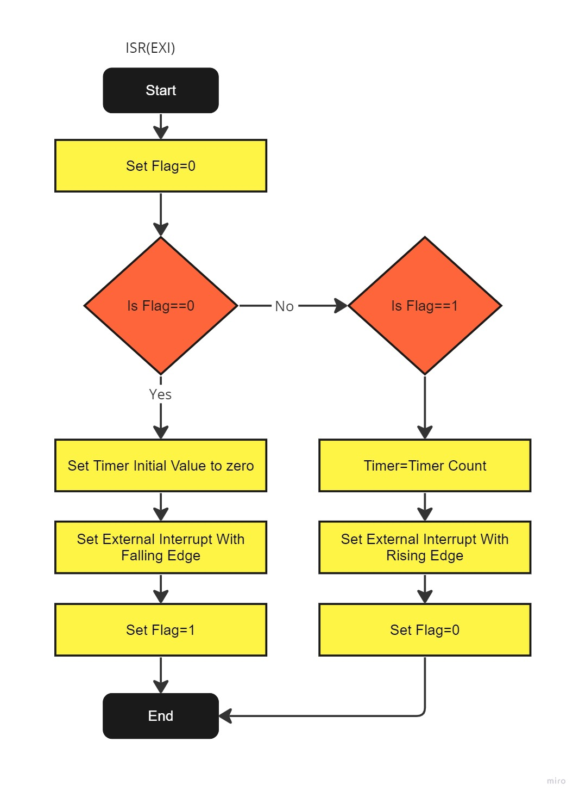

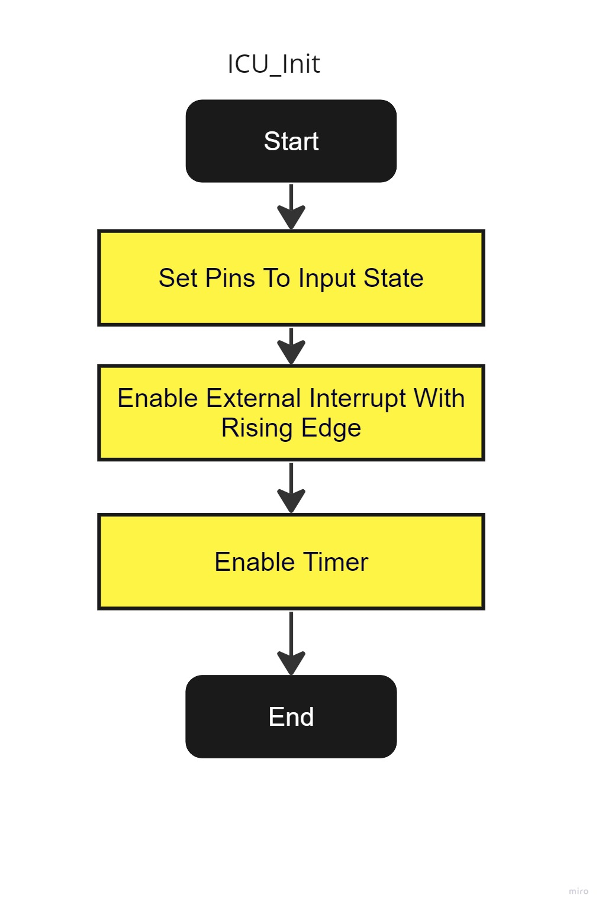

HAL Layer:

LCD Functions:

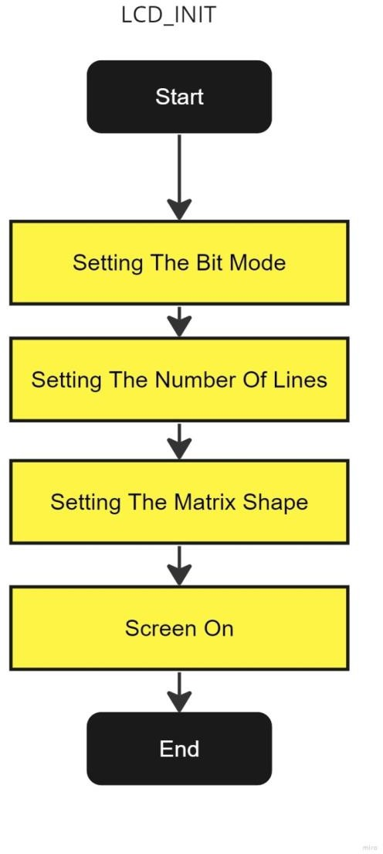
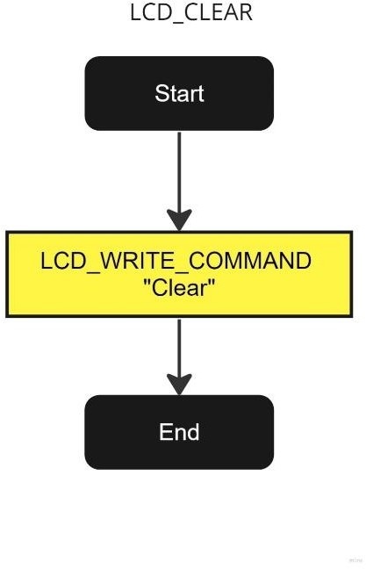

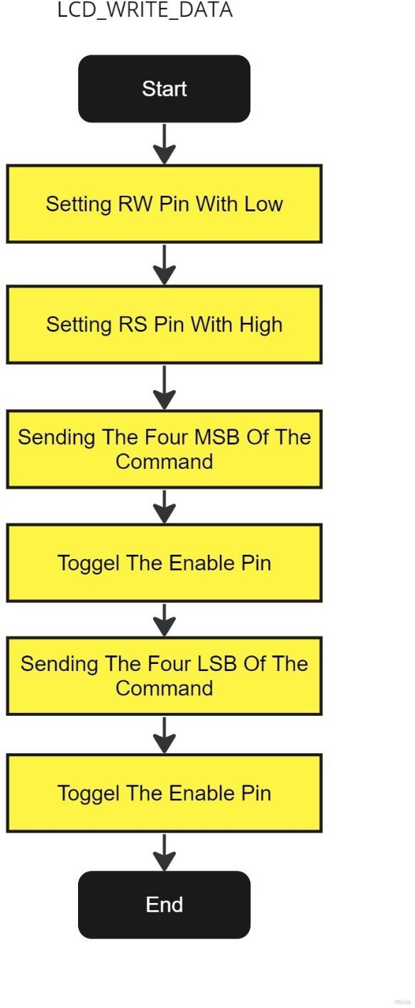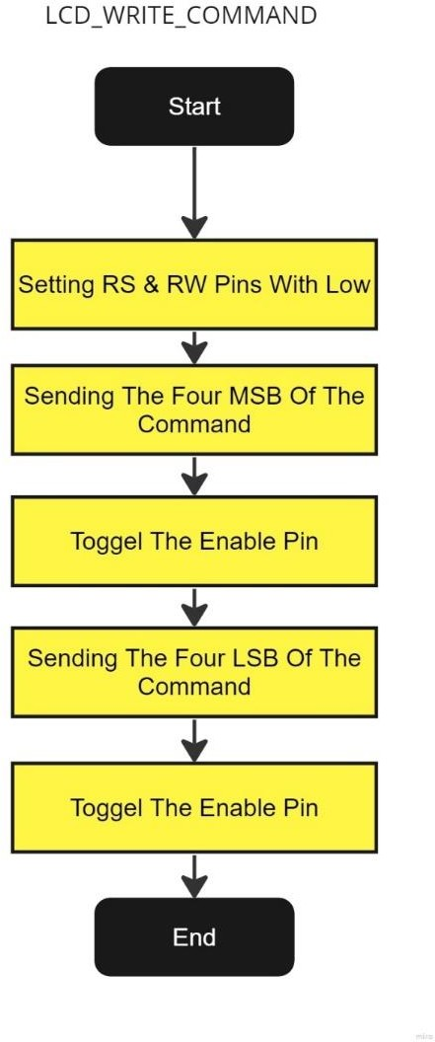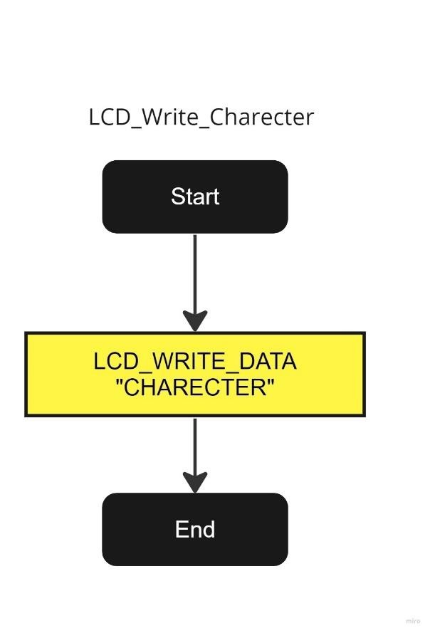

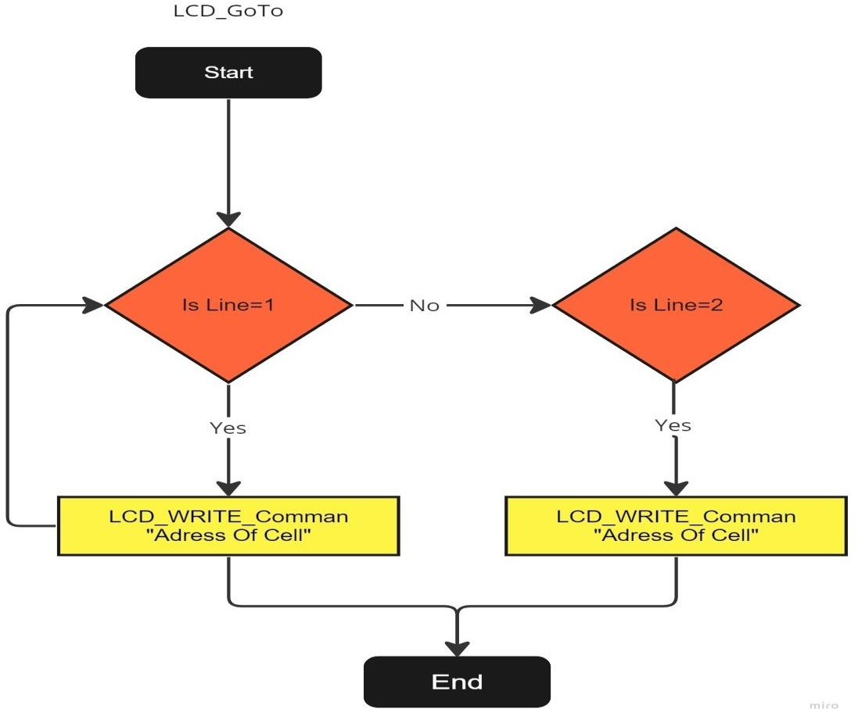

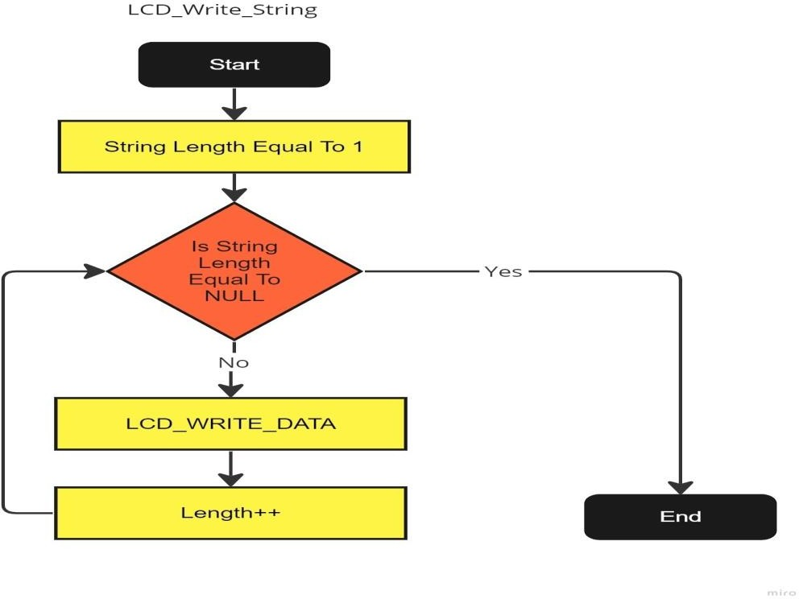

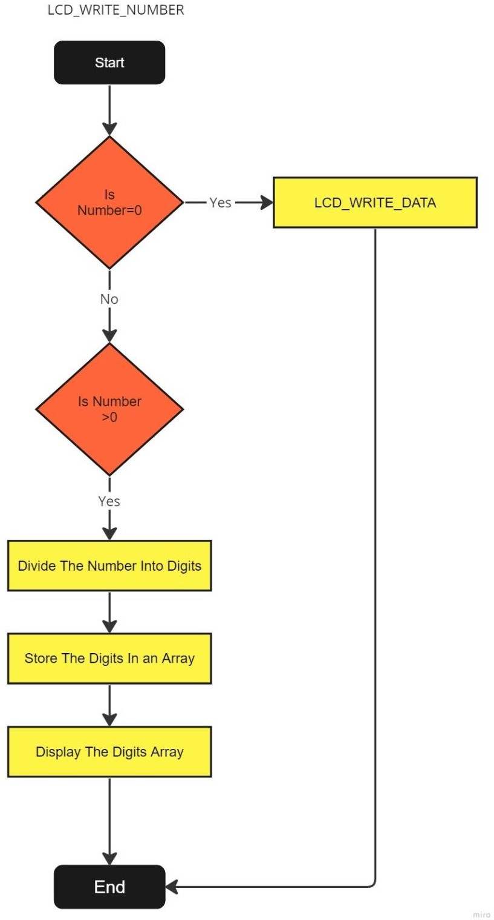

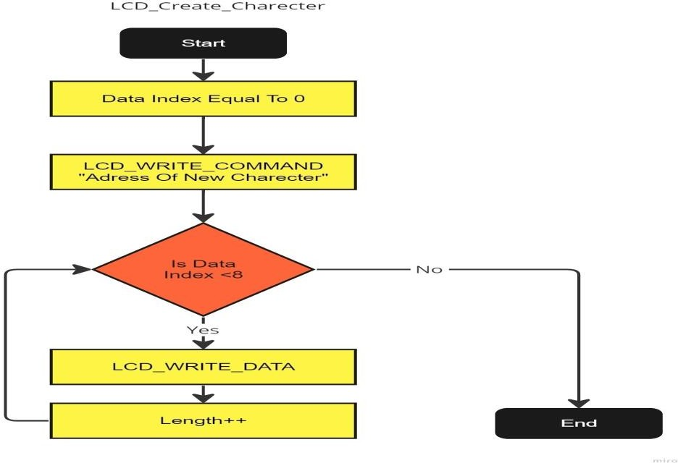

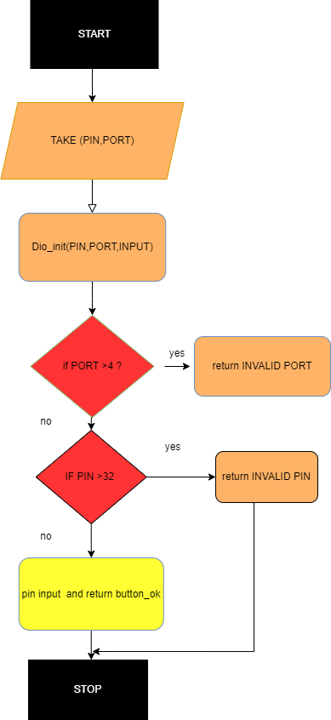
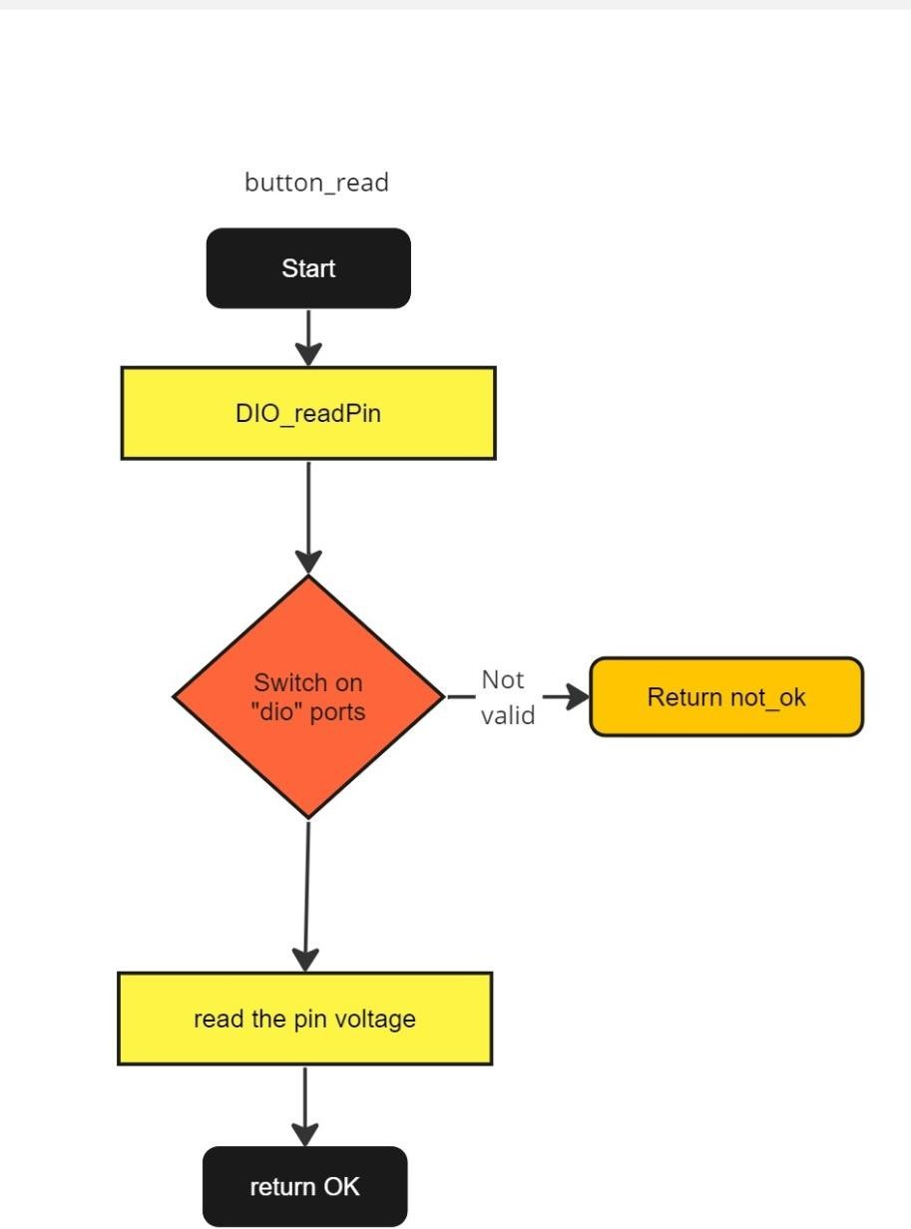Button Functions:
Button_read
Button_INIT

Motor Functions:

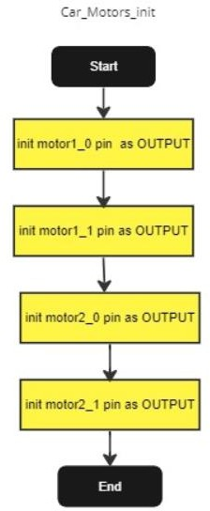

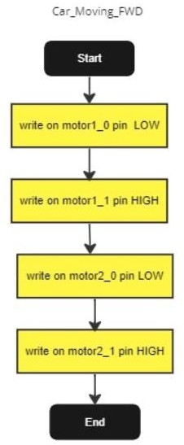

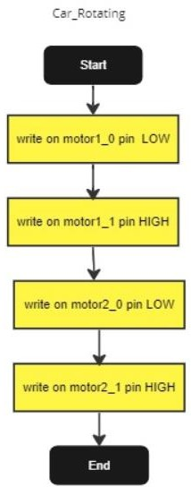

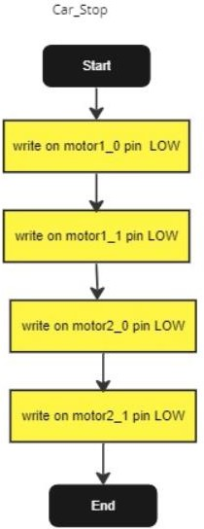

Key Pad Functions:

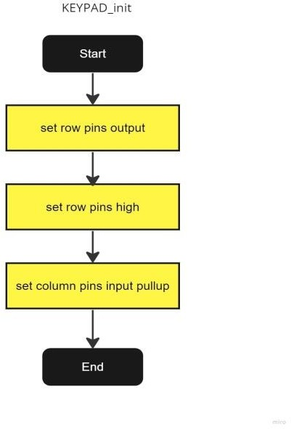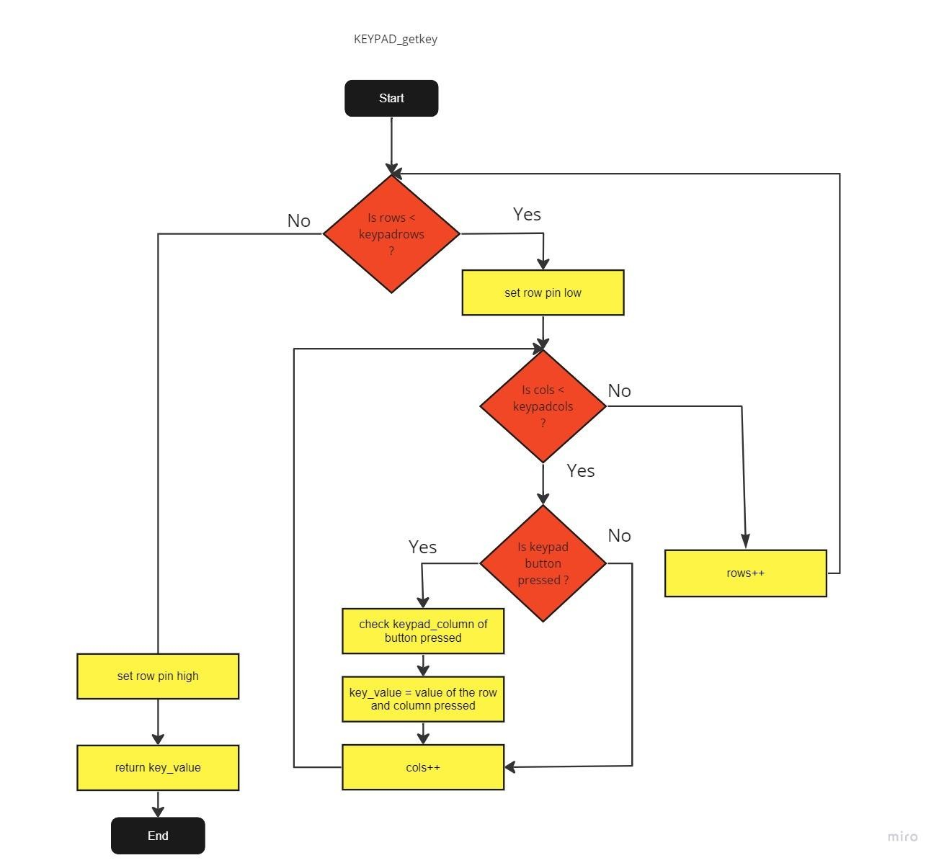

- Ultra Sonic Functions:
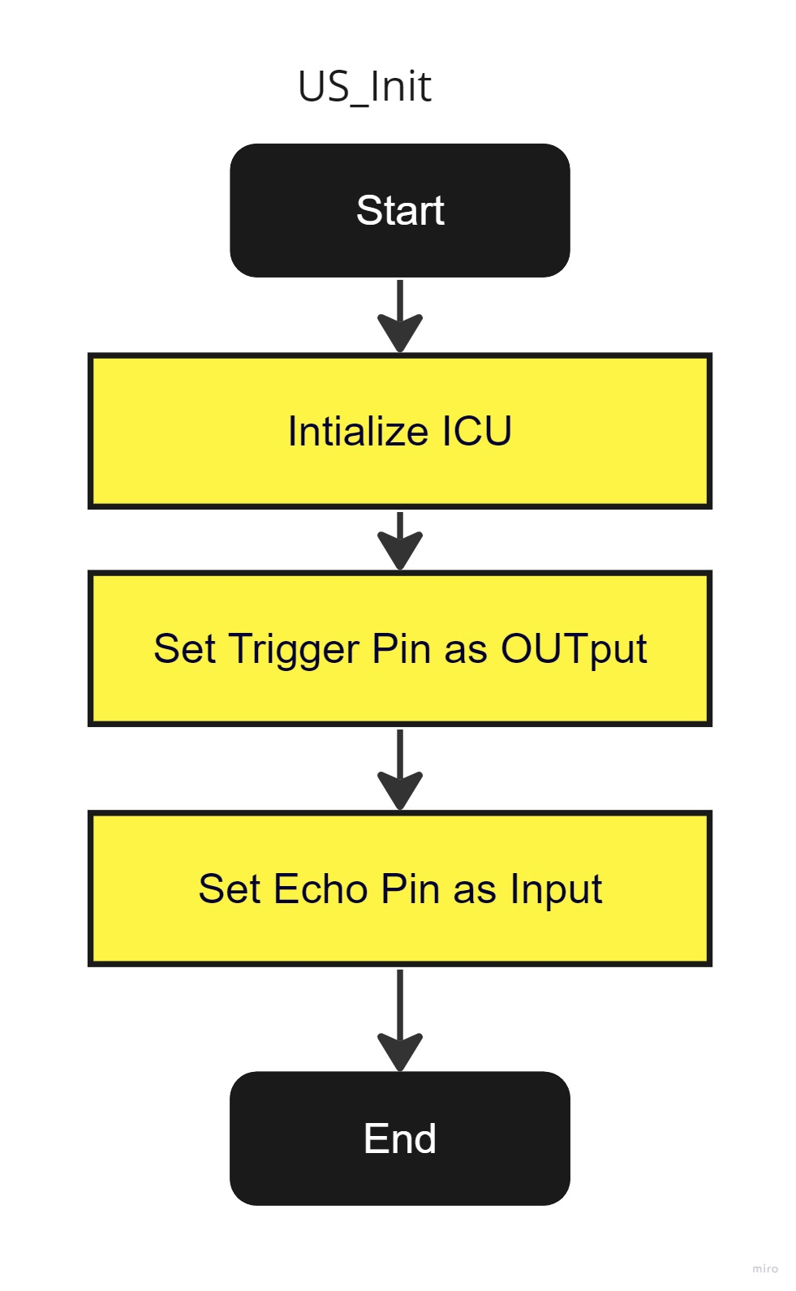
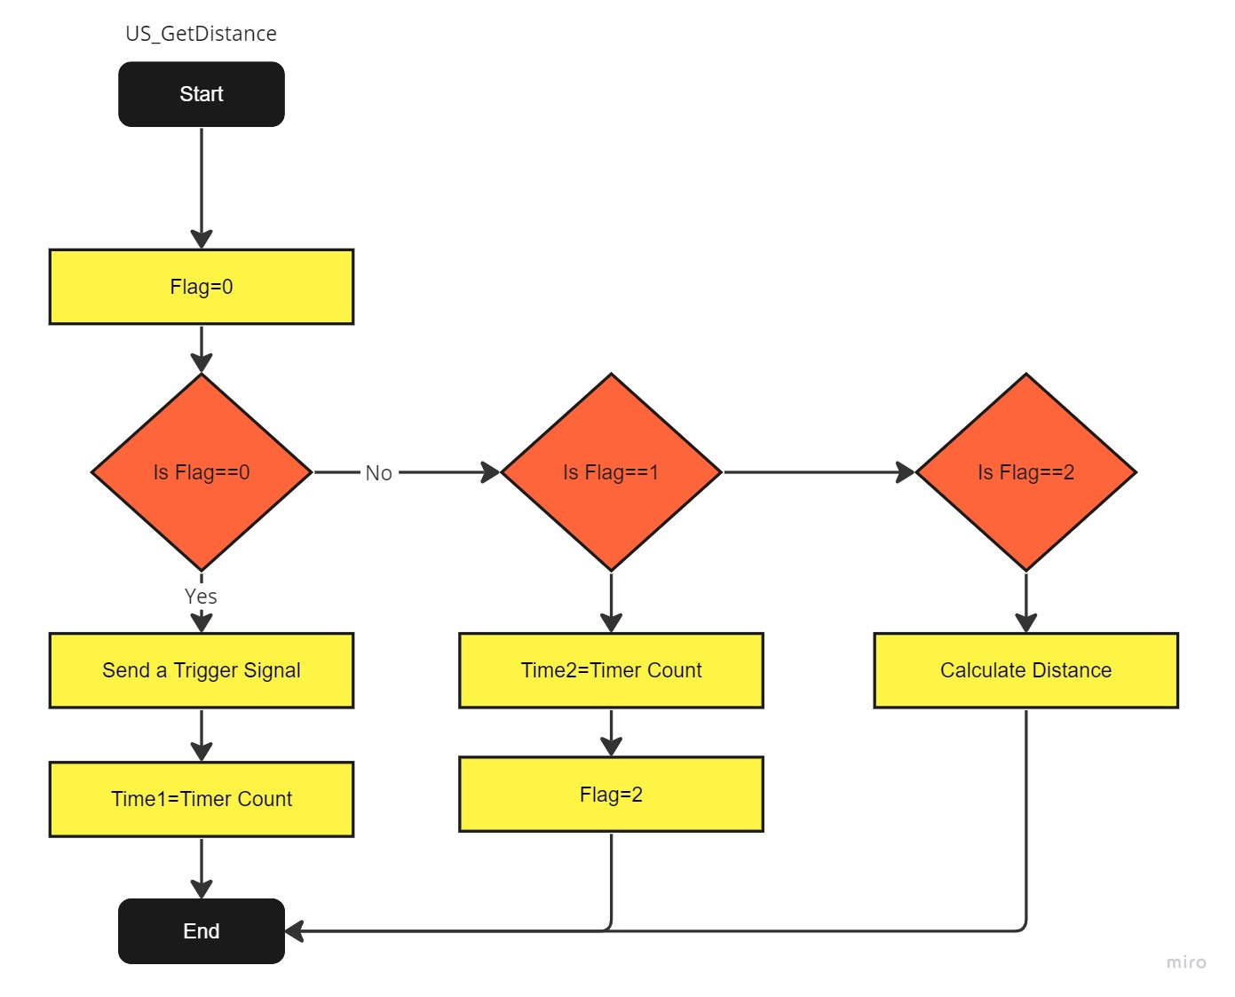

Configurations:-

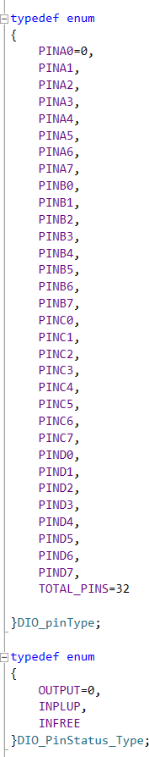Dio:

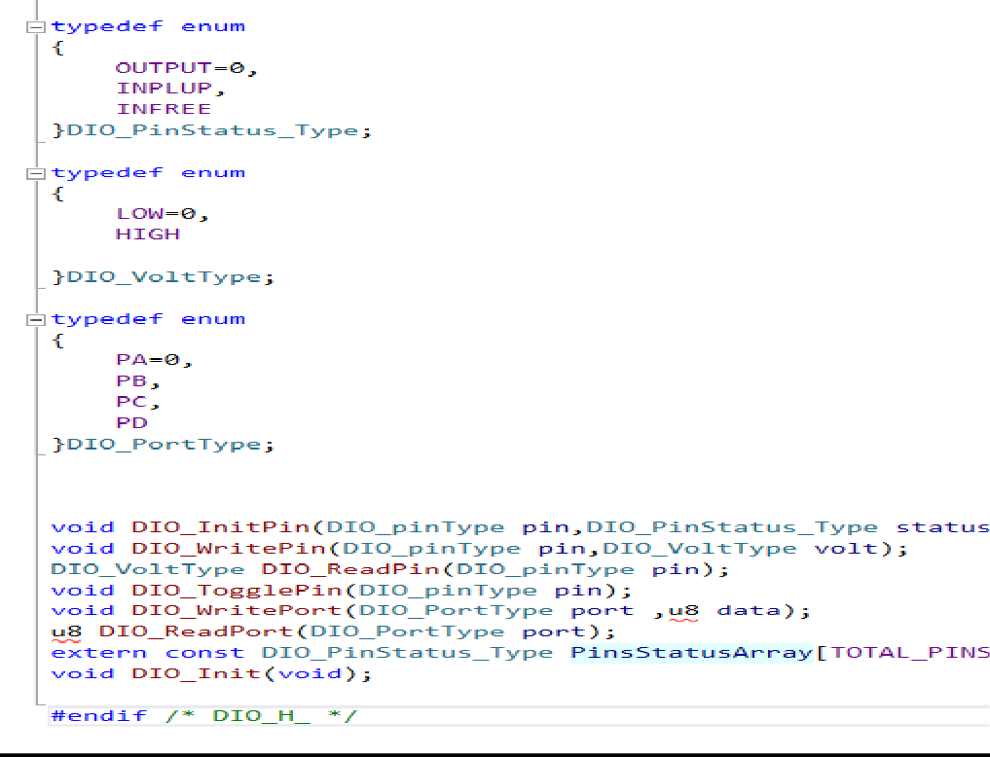

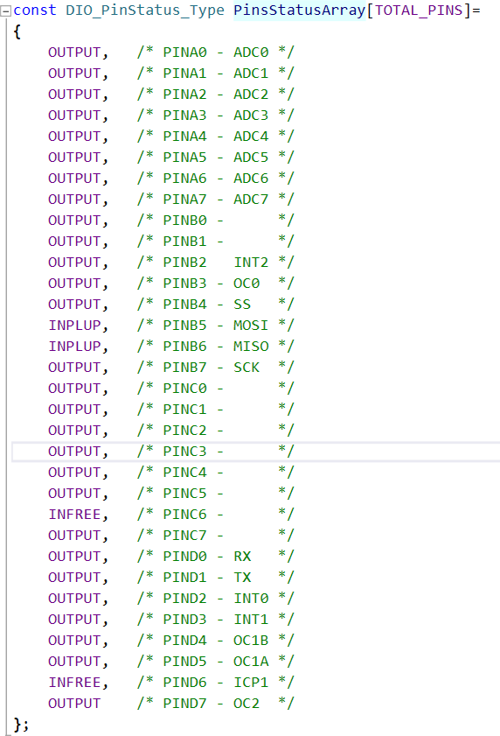

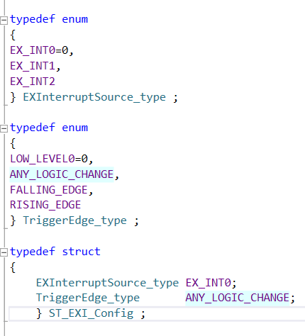EX_Interrupt:

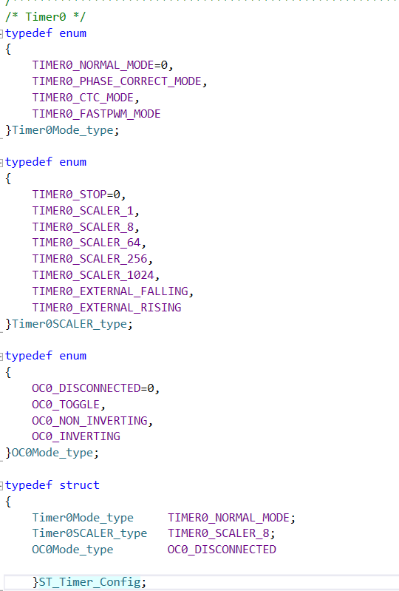
Timers:

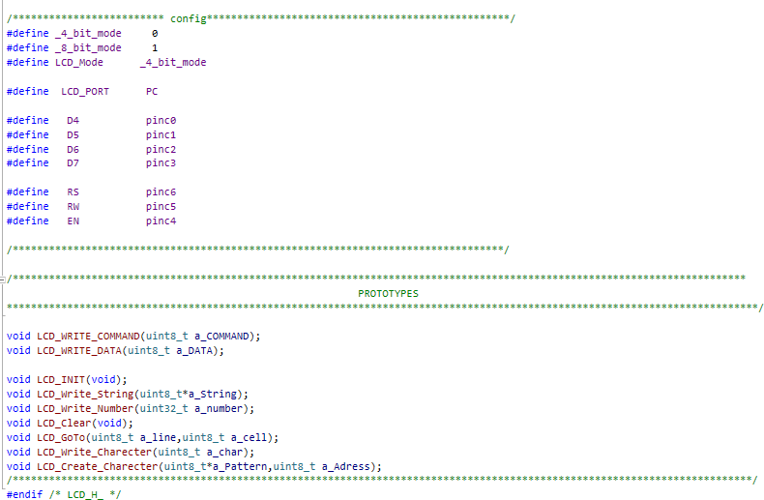
LCD:

